**Wheel of Life**

In this session, we are going to focus on the part of your life that needs most attention right now. We are going to find out what is most important to you in this part of your life and what is needed to move closer to the life you want.

**Wheel of Life Exercise**

**Step 1: Your most important life domains**

In this first exercise, we are focusing on the different domains in your life. Examples of life domains include Money & Finance, Career & Work, Health & Fitness, Fun & Recreation, Environment, Community, Family & Friends, Partner & Love and Growth & Learning. List the most important domains in your life and a brief description each below. List up to 10 life domains (you may also list fewer domains).

These are the most important domains in my life:

Life Domain 1

Life Domain 2

Life Domain 3

Life Domain 4

Life Domain 5

Life Domain 6

Life Domain 7

Life Domain 8

Life Domain 9

Life Domain 10

**Step 2: Entering the life domains in the Wheel of Life**

Now a look at the wheel of life, displayed in the figure on the next page. Enter the names of your most important life domains in the outer rim of the empty wheel.

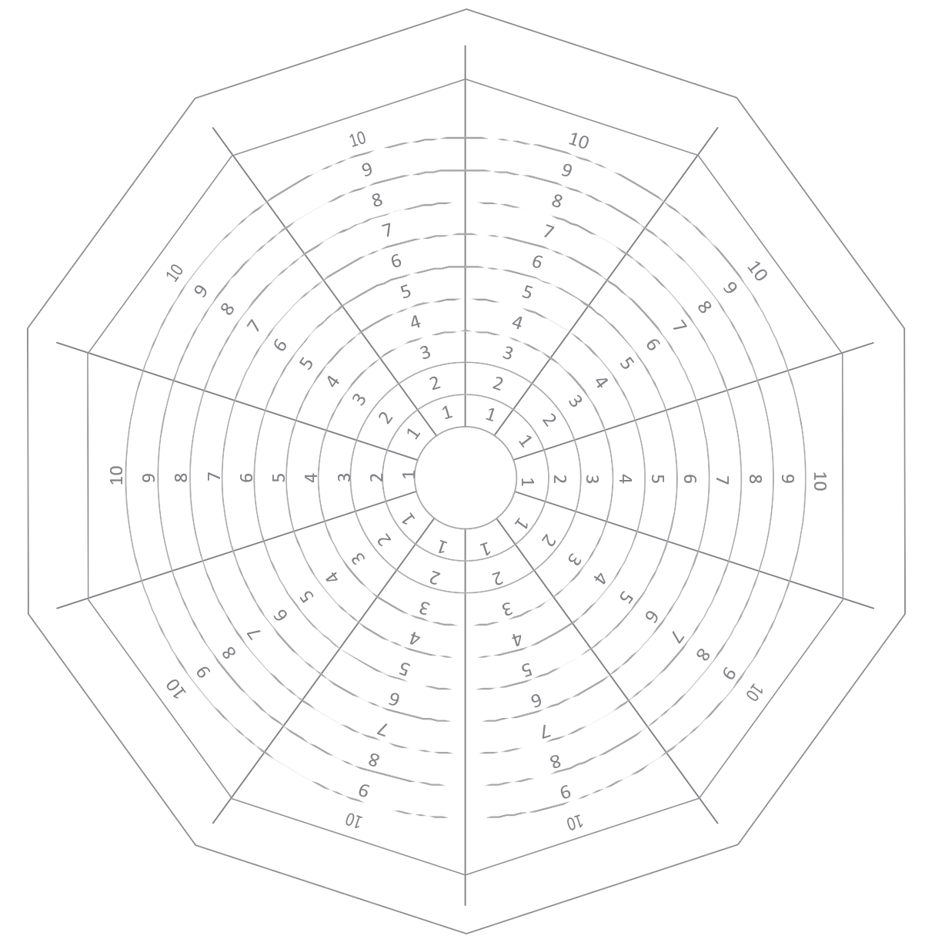

**Step 3: Satisfaction rating of life domains**

Now use the wheel of life to rate your level of satisfaction in the areas you have labelled on the wheel. 1 means that you are not satisfied at all and 10 means you are highly satisfied. Simply highlight the line that corresponds with your level of satisfaction.

**Step 4: Connecting the lines**

Connect the lines to form an inner wheel. For an example, see the picture below.

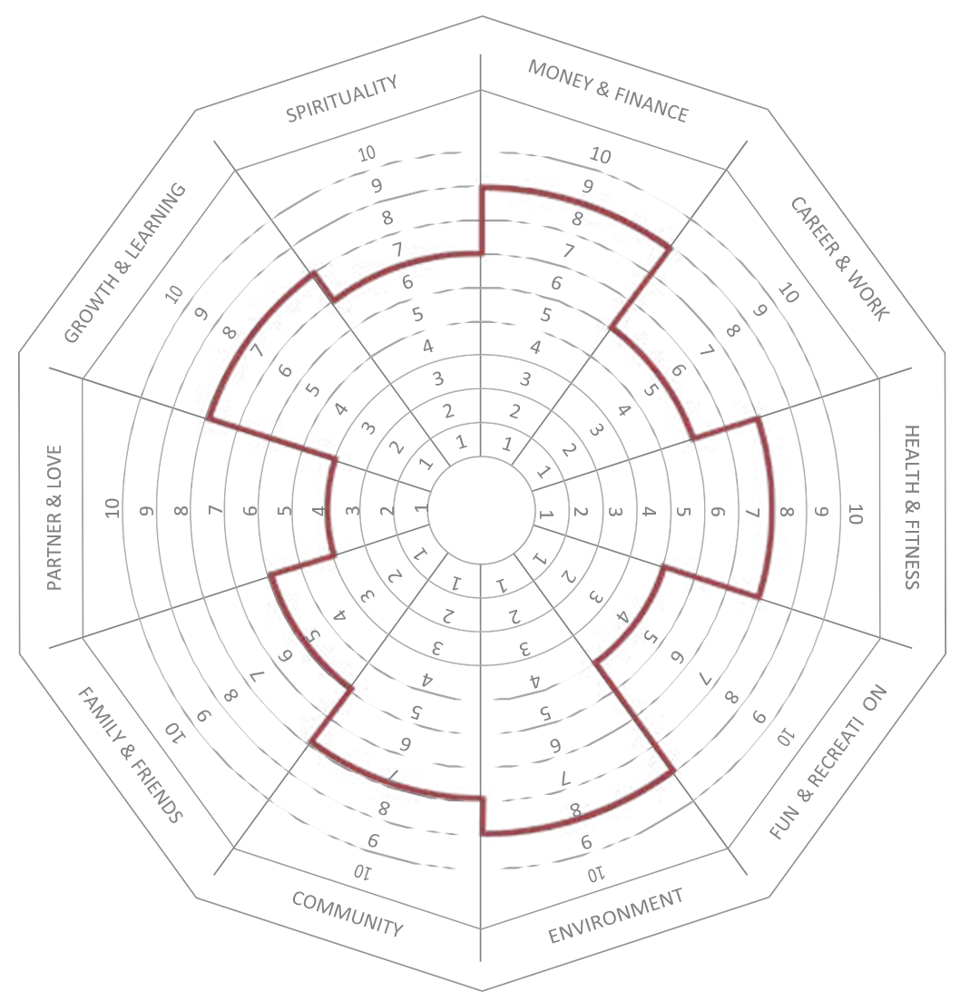

**Step 5: Setting Priorities**

Now take a look at the completed wheel. Are there ways you would want to change the shape of the inner wheel? If so, which domain(s) do you feel need(s) attention?

**These are the life domains that I feel need attention:**

What is the one domain that needs most attention right now? In other words,

What is the domain that you would like to start working on?

**This is the life domain that needs most attention right now:**