Central Adolescent Intake Form
Please answer all questions and print clearly

How did you hear about services at VCS? ____________________________________________

Client Information: (All information kept strictly confidential)

Birth Name:

Chosen Name:

Citizenship: □ US Citizen □ Green Card □ Refugee □ Undocumented

Date of Birth: _______________ Age: _______ Grade in School: ___________________

Pronouns: 󠆶 □ He/Him 󠆶□ She/Her 󠆶□ They/Them 󠆶□ Another____________________________

Address (Street & Number):

Address (City, State, and Zip):

Safe to send mail to the above address? □ Yes □ No

Telephone (Home): _____________________ (Cell): _______________________________

Can we leave a message at the above numbers? □ Yes □ No

Which number should appointment reminders be sent? □ Home □ Cell □ Parents

Email Address: _________________________________________________________________

Safe to send mail to the above email? □ Yes □ No

Session Preference: □ In person □ Remote □ Both

Days Available: □ Monday □ Tuesday □ Wednesday □ Thursday □ Friday □ Open

Times Available: □ Morning (9-12) □ Afternoon (12-4) □ Evening (5- 8) □ Open

Transportation problem: □ Yes □ No

Emergency Contact: ________________________ Phone Number: ______________________

Racial/Ethnic Ancestry:
□ White/Caucasian □ Black/African American □ Hispanic/Latino □ Caribbean □ Asian
□ Indigenous/Native □ Hawaiian or Other Pacific Islander

Current Relationship Status:
□ Single □ Married □ Couple Relationship □ Separated □ Divorced □ Widowed (How long?) ____

Family History:

Please list all persons living in your home

Name | Relationship | Age

Please list all family not living with you

Name | Relationship | Age

Are all your parents/guardians living? □ Yes □ No
If not, who? _____________________Your age when they died? _______________

Are you or have you been physically punished at home? □ Yes □ No

Self-Assessment:

What are your main concerns? ___________________________________________________

Do you feel depressed? □ Yes □ No

Do you get angry easily? □ Yes □ No

Do you feel anxious? □ Yes □ No

What do you wish you could change in your life? (Check all that apply)

□ Parents □ School □ Friends □ Myself □ Alcohol/Drug use □ Feeling I don’t fit in □ Weight

What do you like to do (interest, hobbies)?

What jobs or careers are you interested in for the future?

Alcohol and Drugs:

How often do you drink alcohol? □ Daily □ Weekly □ Rarely □ Never

How often do you use street drugs? □ Daily □ Weekly □ Rarely □ Never

How often do you use marijuana? □ Daily □ Weekly □ Rarely □ Never

How often do you use vape or Juul? □ Daily □ Weekly □ Rarely □ Never

Weight, Eating and Hunger:

Do you eat too much or too little to affect your weight or appearance? □ Yes □ No

Does thinking about your weight or appearance make it difficult to concentrate? □ Yes □ No

Do you sometimes purposefully throw up after eating? □ Yes □ No

Do you feel hungry but do not have enough food to eat? □ Often □ Sometimes □ Never

Social and School:

Do you have friends? □ Yes □ No

Do you have people you are close to and are able to confide in? □ Yes □ No

Are you in a special program at school? □ Yes □ No
If yes, do you have: □ IEP □ IESP □ 504

Do you have problems with teachers at school? □ Yes □ No

Do you get into fights at school? □ Yes □ No

Have other students ever teased, hit, bullied (including online) or said mean things to you? □ Yes □ No

Are you a member of, connected to, or have had any problems with a gang? □ Yes □ No

Do you ever have concerns about your use of social media? □ Yes □ No

Does social media ever get in the way of participating in other activities? □ Yes □ No

Self-Injury:

Have you ever cut yourself on purpose? □ Yes □ No

Does anyone know about it? □ Yes □ No

Have you ever physically hurt yourself on purpose? □ Yes □ No

Does anyone know about it? □ Yes □ No

Have you ever thought about suicide? □ Yes □ No

Have you ever attempted suicide? □ Yes □ No

Does anyone know about it? □ Yes □ No

Sex and Gender:

Do you think of yourself as:
□ Straight or heterosexual □ Lesbian or gay □ Bisexual
□ Something else □ Don’t know □ Choose not to disclose

What is your current gender identity?
□ Male □ Female □ Intersex
□ Transgender Male / Trans Man / Female-to-Male (FTM)
□ Transgender Female / Trans Woman / Male-to-Female (MTF)
□ Genderqueer, neither exclusively male nor female
□ Additional Gender Category / (or Other), please specify: ________________
□ Choose not to disclose

What sex were you assigned at birth on your original birth certificate?
□ Male □ Female □ Choose not to disclose

Would you like to discuss your gender identity or sexual orientation? □ Yes □ No □ Maybe

Are you currently sexually active? □ Yes □ No

Have you ever had sex in the past? □ Yes □ No

Have you ever been pregnant or got someone pregnant? □ Yes □ No

Have you ever had any kind of sexual contact that felt upsetting at the time or later? □ Yes □ No

Has anyone ever asked you to have sex in exchange for money or something else? □ Yes □ No

Trauma:

Have you experienced any of the following events? (Check all that apply):
□ Car accident
□ Alcoholism or drug use in the home by a family member
□ Sudden death of a family member or close friend
□ Serious injury or life-threatening event
□ Major medical operation or event
□ Witnessing a violent upsetting event
□ Physical, emotional, verbal or sexual abuse
□ Bullying at school
□ Incarceration of a parent or caregiver
□ Major medical or mental health illness of a family member in the home’
□ Separation or divorce of parents or caregivers

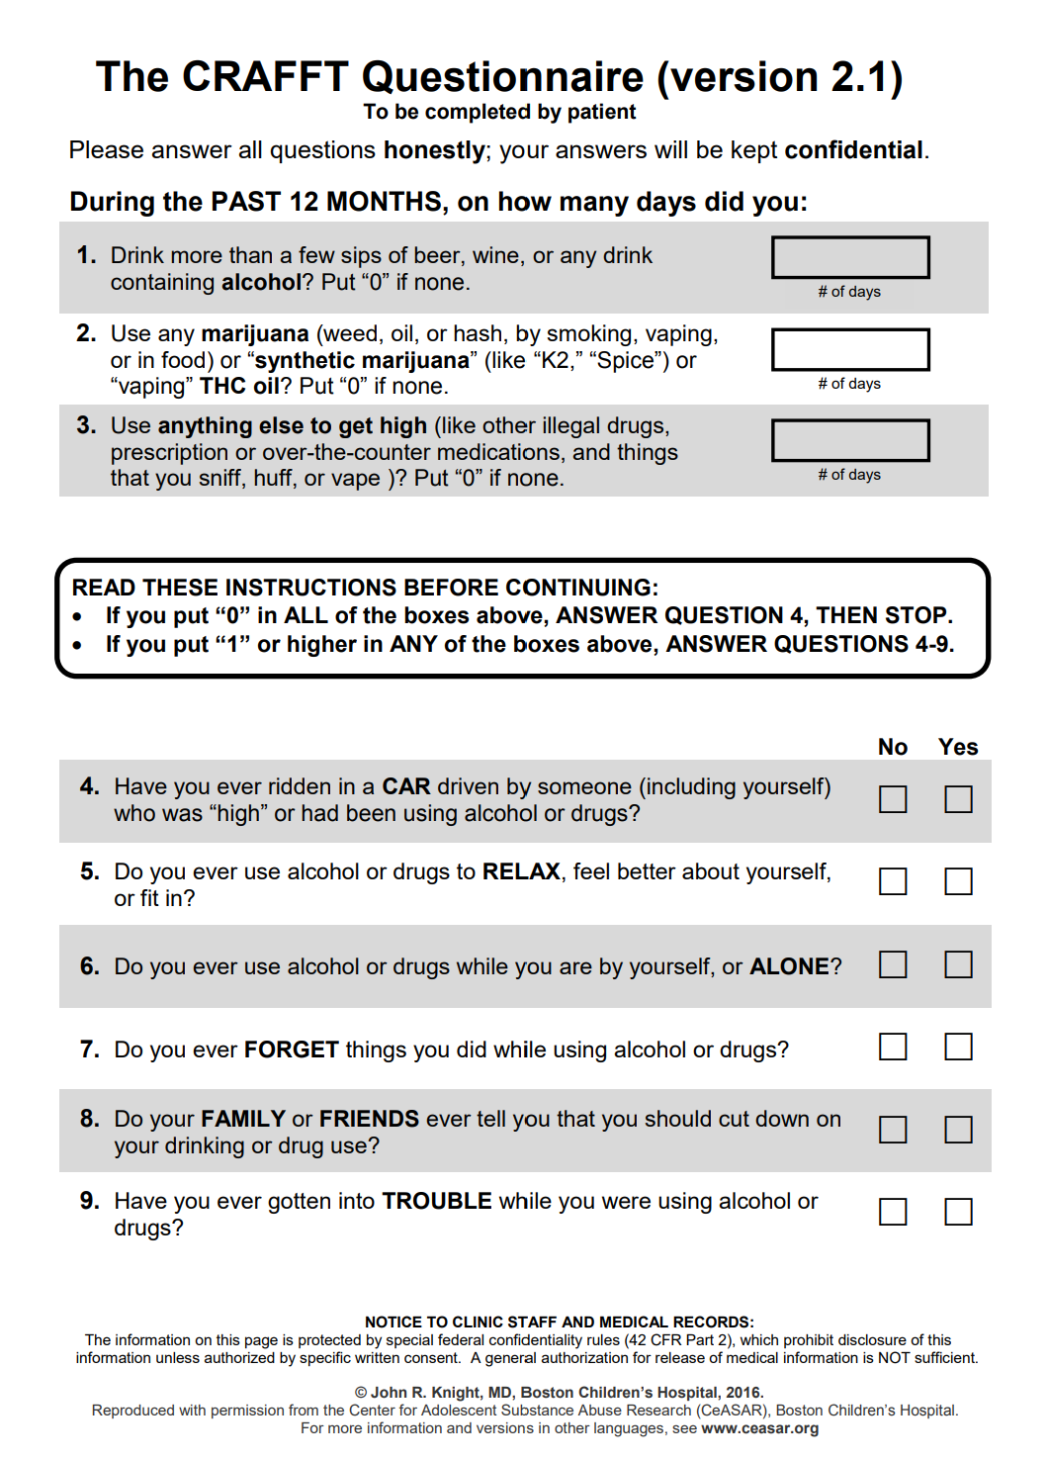
Rapid Opioid Dependence Screen (RODS)
Do not complete for children aged 11 or under

The following questions are about your prior use of drugs. For each question, please indicate “yes” or “no” as it applies to your drug use during the last 12 months.

- Have you taken any of the following drugs?
Heroin ○ Yes ○ No
Methadone ○ Yes ○ No
Buprenorphine ○ Yes ○ No
Morphine ○ Yes ○ No
MS CONTIN ○ Yes ○ No
OxyContin ○ Yes ○ No
Oxycodone ○ Yes ○ No
Other opioid analgesics ○ Yes ○ No
(e.g., Vicodin, Darvocet, etc.)

If you answered yes to any of the above, please proceed to the following questions:
2. Did you ever need to use more opioids to get the same high as when you first started using opioids?
○ Yes ○ No
3. Did the idea of missing a fix (or dose) ever make you anxious or worried?
○ Yes ○ No
4. In the morning, did you ever use opioids to keep from feeling “dope sick” or did you ever feel “dope sick”?
○ Yes ○ No
5. Did you worry about your use of opioids?
○ Yes ○ No
6. Did you find it difficult to stop or not use opioids?
○ Yes ○ No
7. Did you ever need to spend a lot of time/energy on finding opioids or recovering from feeling high?
○ Yes ○ No
8. Did you ever miss important things like doctor’s appointments, family/friend activities, or other things because of opioids?
○ Yes ○ No
Created by Sandra A. Springer, MD

SBQ-R Suicide Behaviors Questionnaire-Revised

Patient Name _____________________________________ Date of Visit__________________

Instructions: Please check the number beside the statements or phrase that best applies to you.

- Have you ever thought about or attempted to kill yourself? (check one only)
- 1. Never
- 2. It was just a brief passing thought
- 3a. I have had a plan at least once to kill myself but did not try to do it
- 3b. I have had a plan at least once to kill myself and really wanted to die
- 4a. I have attempted to kill myself, but did not want to die
- 4b. I have attempted to kill myself, and really hoped to die

- How often have you thought about killing yourself in the past year? (check one only)
- 1. Never
- 2. Rarely (1 time)
- 3. Sometimes (2 times)
- 4. Often (3-4 times)
- 5. Very Often (5 or more times)

- Have you ever told someone that you were going to commit suicide, or that you might do it? (check one only)
  - 1. No
  - 2a. Yes, at one time, but did not really want to die
  - 2b. Yes, at one time, and really wanted to die
  - 3a. Yes, more than once, but did not want to do it
  - 3b. Yes, more than once, and really wanted to do it

- How likely is it that you will attempt suicide someday? (check one only)
- 0. Never
- 1. No chance at all
- 2. Rather unlikely
- 3. Unlikely
- 4. Likely
- 5. Rather likely
- 6. Very likely

PATIENT HEALTH QUESTIONNAIRE-9
(PHQ-9)
Over the last 2 weeks, how often have you been bothered by any of the following problems? (Use “✔” to indicate your answer) | Not at all | Several days | More than half the days | Nearly every day
1. Little interest or pleasure in doing things | 0 | 1 | 2 | 3
2. Feeling down, depressed, or hopeless | 0 | 1 | 2 | 3
3. Trouble falling or staying asleep, or sleeping too much | 0 | 1 | 2 | 3
4. Feeling tired or having little energy | 0 | 1 | 2 | 3
5. Poor appetite or overeating | 0 | 1 | 2 | 3
6. Feeling bad about yourself — or that you are a failure or have let yourself or your family down | 0 | 1 | 2 | 3
7. Trouble concentrating on things, such as reading the newspaper or watching television | 0 | 1 | 2 | 3
8. Moving or speaking so slowly that other people could have noticed? Or the opposite — being so fidgety or restless that you have been moving around a lot more than usual | 0 | 1 | 2 | 3
9. Thoughts that you would be better off dead or of hurting yourself in some way | 0 | 1 | 2 | 3

FOR OFFICE CODING 0 + ______ + ______ + ______
=Total Score: ______

If you checked off any problems, how difficult have these problems made it for you to do your work, take care of things at home, or get along with other people?
Not difficult  at all | Somewhat  difficult | Very  difficult | Extremely difficult
VCS Inc. Client Responsibilities
Adolescent

- All counseling sessions are confidential.
However, by law, VCS has a legally mandated duty to warn if you are a danger to yourself or someone else. If this applies, you will be informed before any action is taken.

- If you need to cancel an appointment, VCS must be notified at least 24 hours in advance. There is a fee for late cancellations or no-shows.

- If you miss an appointment, we will try to help resolve any issues that are making it difficult to attend. If despite this, you miss another consecutive appointment without good reason you may lose your recurring appointment. If you subsequently do not make and show for an appointment within two weeks, your file will be closed.

- There are NO weapons allowed on the premises of VCS. That includes anything that may be considered a weapon such as a pocket or utility knife. If you have a weapon, you will be asked to leave, and your appointment will be rescheduled.

- VCS clients sometimes ask for referrals to other service providers and/or agencies. If we provide a list of suggestions, please use it as a guide. Any such referrals are not to be taken as endorsements.

Please note: Intake fees are non-refundable

I CERTIFY THAT I HAVE READ AND UNDERSTAND THE ABOVE INFORMATION.
I AGREE TO ABIDE BY THESE TERMS.

_________________________________________________ _________
PLEASE PRINT NAME DATE

_________________________________________________ _________
SIGNATURE DATE

